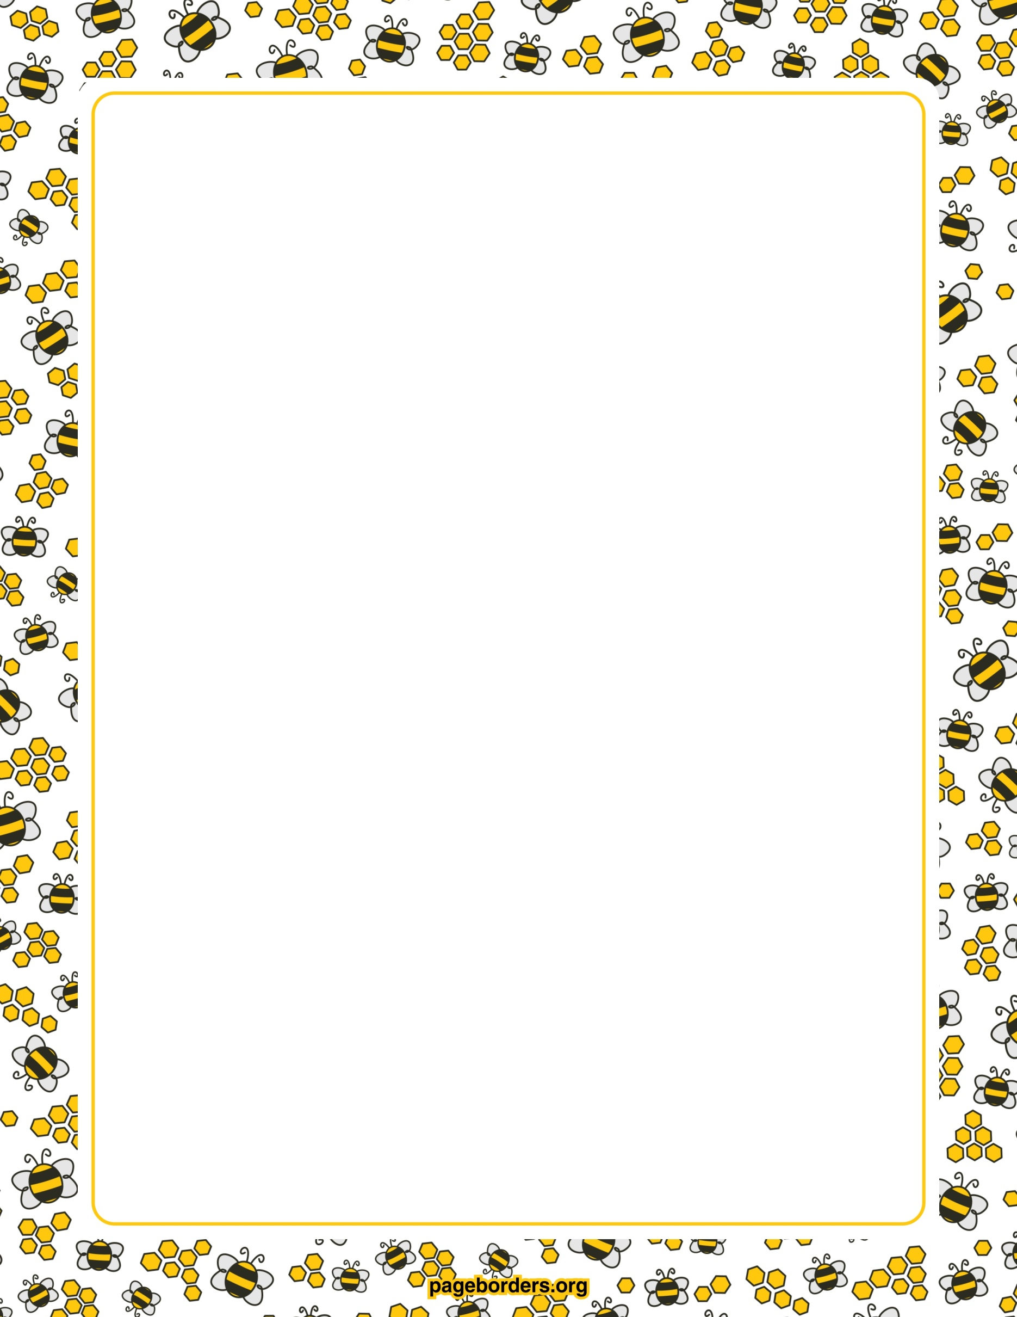
‘Career Education 8’ 2022-23

Assignment #3: What kind of world am I creating?

Instructions:
Over the next two weeks complete the three assigned activities on GLOBAL CITIZENSHIP (being a good community member, locally and globally). Complete and submit to Mr. Muscardin.

Curriculum:
Big Ideas | The value of work in our lives, communities, and society can be viewed from diverse perspectives.  Our career paths reflect the personal, community, and educational choices we make.
Curricular Competencies | Question self and others about how individual purposes and passions can support the needs of the local and global community when considering career choices.  Recognize the impact of personal public identity in the world of work.  Demonstrate respect, collaboration, and inclusivity in working with others to solve problems.  Recognize and explore diverse perspectives on how work contributes to our community and society.  Demonstrate safety skills and appreciate the importance of workplace safety.  Question self and others about the role of family expectations and traditions, and of community needs in career choices.  Explore volunteer and other new learning experiences that stimulate entrepreneurial and innovative thinking.  Apply decision-making strategies to a life, work, or community problem and adjust the strategies to adapt to new situations.
Content | Personal development:  - Project management  - Reflection  Connections to community:  - Career value of volunteering  - Cultural and social awareness  - Local and global needs and opportunities  Life and career plan:  - Role of community, school, personal network, and mentorship in career planning  - Role of mentors, family, community, school, and personal network in decision making  - Workplace safety

Imagi-NATION

Instructions:
Imagine that you are the ruler of the world! You are to begin drafting your perfect community: what types of rules exist, what types of activities do people get to do, etc.? Fill out the speech bubbles below to show what your world would look like. Each of the six categories must contain at least 5 details (bullet points are okay). Remember that you want to create a place that is kind and inclusive, runs smoothly, and takes good care of all of its citizens. Your answers can draw on real-world examples, and/or can be completely made up by you. Give your perfect a world a name too
Hello there!

My name is ___________
_______________
_______________.

I am the perfect place! Here is what I look like:

My perfect world looks like:
System of Governance and  Leadership Structure | Important Rules, Laws, and  Customs
Taking Care of People’s Basic  Needs (food, shelter, water, health) | School and Common Jobs
Entertainment and Fun | Other Important Details

Cyber Citizenship

Instructions:
As you are completing your Career Education course online via TEAMs, now is an excellent opportunity for us to examine what it means to be a good cyber citizen! Just like we want to be kind, caring, and contributing citizens in real life, it is important to conduct ourselves that way on the internet too. Complete the charts and questions below about your current online behaviors and ‘netiquette.’

My online habits:
What I do online | How many hours I spend on this platform | How I feel when using this platform
Example:  Instagram – upload photos, scroll through friends’ photos, follow celebrities | 3 hours per week | Happy, proud Silly Loved, connected  Sad, lonely, worried Angry

Happy, proud Silly Loved, connected

Sad, lonely, worried Angry

Happy, proud Silly Loved, connected

Sad, lonely, worried Angry

What is a digital habit that you have that is good? (For example, connecting with friends or family, limiting your screen time, finding resources for school work.) _________________________
______________________________________________________________
What makes this a good habit? ___________________________________________
______________________________________________________________
______________________________________________________________

What is a digital habit that you have that you could improve on? (For example, using kind words online, staying on safe websites.) __________________________________________
______________________________________________________________
Why do you need to improve this habit? _____________________________________
______________________________________________________________
What can you do to improve this habit? ______________________________________
______________________________________________________________
______________________________________________________________

My profiles:
Our digital selves are just one part of our whole, true self. What we show online is not the 100% real version of us—only we can know our own 100% self, and even that self is constantly growing and changing. Therefore, what we share on the internet is just a partial representation of the person behind the screen. It is important to represent ourselves in a safe, responsible, and authentic manner.

Logout of all your social media accounts. Now Google your name (in both the general and images search tabs). What you see is what a future employer or any person Googling you would see. What did you find? __________________________________________________________
______________________________________________________________
______________________________________________________________
______________________________________________________________
______________________________________________________________
______________________________________________________________
______________________________________________________________
______________________________________________________________

If you found anything inappropriate, embarrassing, or mean, now is the time to delete it! (And do not repeat it!) Remember that once something is on the internet, it is no longer in your control; only post what belongs to you and that you can be proud of ANYONE seeing.

This also means that before you share something, check that it is accurate. Find information from first-hand sources and fact-check it amongst other reputable sources (such as well-established news sites, academic journals, and scientific websites). If a webpage does not give you any contact information, or the author does not have any credentials related to the topic they are speaking about, they are likely not someone you should be relying on for information. Just because something is written on the internet (including Wikipedia) does NOT make it true!
Canadian Volunteer Directory

Instructions:
Now that you’ve created the perfect imaginary world and looked at internet safety, let’s look at a website that can help us make our world better too! Volunteering is a great way to help out others in your community, while also enjoying yourself. Go to the following website (the Canadian Volunteer Directory): http://www.canadian-universities.net/Volunteer/. Select “British Columbia” and “Surrey” (or whichever city you live in). This website has MANY links to other organizations who are looking for help. Click on an agency that you could imagine yourself volunteering at in the future, and answer the questions below using both the CVD website information and the organization’s webpage too.
Hint: it may help you to also use the “filter by organization” option to limit your search results to sites of interest.

My volunteer location:
Name of the agency I researched
Link to their website
The reason I was interested in this agency is…
What do volunteers do at this agency?
What are the requirements for volunteering here?
RAK Attack

Instructions:
It is important to remember how powerful you are: every action you take has a ripple effect on those around you, and little ripples get bigger and bigger as they continue on. Volunteering is great, but you can make a big difference on your own every day too. The last activity in this assignment is to use your power for good by launching a RAK attack! What is RAK? A random act of kindness! Your RAK attack can be as big or little as you like: helping your family complete extra chores, writing a kind letter to someone, shoveling a neighbor’s snow, or donating your time or money to a cause you care about. Launch your RAK attack, and then reflect on it below.

My RAK attack response:
What was your RAK attack?
Who was your RAK attack on?
How do you think the recipient(s) felt? Explain.
Write a journal entry about your RAK attack.

Some questions to consider are:
- Why did you decide to do your specific RAK attack activity?
- How did your RAK attack make you feel?
- Would you do this RAK attack again? If you did, would it be on someone else?
- What are some other RAK attacks you could do in the future? Who would benefit from them?

