Math 8 Muscardin
Name: ________________________

Chapter 2 – Exponents

Test Date: ________________________________________

To do:

2.1 – Exponents
- Complete Notes ⃝

2.2 – BEDMAS
- Complete Notes ⃝

2.3 – Square Roots of Perfect Squares
- Complete Notes ⃝
- Quiz 1 ⃝

2.4 – Square Roots of Whole Numbers
- Complete Notes ⃝

2.5 – Pythagorean Theorem
- Complete Notes ⃝

2.6 – Cubes and Cube Roots
- Complete Notes ⃝
- Quiz 2 ⃝

Assignments
- Chapter Assignment ⃝

Write Unit Test ⃝

Math 8 Lesson 2.1 - Exponents Muscardin

An exponent is a quantity representing the ___________________________ to which a given number or expression is to be ______________________. Expressed as:

Examples:
- Expand and evaluate:
  - $6^{3}$

  - $9^{7}$

A ______________________________________ is the result of when a number is _____________________________________ by itself. For example:

Any whole number multiplied by itself will result in a __________________________________.
Perfect Squares:
Number | Number Squared | Perfect Square

Math 8 Lesson 2.2 - BEDMAS Muscardin

A special order of operations is to be done when there are several operations needed to simplify an expression.

B
E
D
M
A
S

Examples:
- ${(5-3)}^{2}+18÷2$ 2. $\frac{4^{3}+6}{5×2}$

Math 8 Lesson 2.3 – Square Roots of Perfect Squares Muscardin

Finding the square root of a number is the ____________________________________ of a number squared. For example:

You can use prime factorization to find the square root of a perfect square. For example:

Another way to find the square root of a number is to find all the ___________________ of the number. Factors are all the numbers that _____________________________________ into it. For example:

Whenever a number has _____________________________________________________ that factor is the square root of the number. So a perfect square will have an _________________ number of factors. For example:
Examples:
- $\sqrt{81}$ $\sqrt{49}$ $\sqrt{400}$

- Solve for $x$
$x^{2}=36$ $x^{2}=25$ $x^{2}=9$

- Use prime factorization and factors to evaluate.
$\sqrt{324}$

Math 8 Lesson 2.4 – Square Roots of Whole Numbers Muscardin

The square root of a number can also be determined by ________________________________
____________________________ whose area is equal to that number. For example:

We can approximate the square root of a _______________________________ that is not a perfect square by determining what _________ perfect squares it is ___________________. We use the perfect squares as benchmarks. For example:

Once you have an approximate value you can use _____________________________________ to be more accurate. (Use a number line)

A more accurate way of finding square roots of non-perfect numbers is to use a _______________________________________. It is important to understand how this tool works in order to correctly input the calculation to get the correct outcome! For example:

Examples:
- Use your calculator to evaluate. Round your answer to 2 decimal places.
$\sqrt{88}$ $\sqrt{32}$

- Approximate:
$\sqrt{41}$ $\sqrt{13}$ $\sqrt{82}$

Math 8 Lesson 2.5 – Pythagorean Theorem Muscardin

Pythagoras, a Greek mathematician, showed that in any right triangle, there is a special relationship among the ________________________. A right triangle is one that has two sides that form a _____________________________________. The side opposite the right angle is called the ____________________________ and the two shorter sides are called ___________.
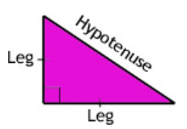
He found that: The area defined by the square of the hypotenuse equals the sum of the areas defined by the squares of the other two sides.
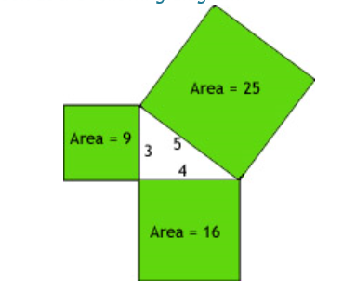

Hence,

Examples:
- Solve for the unknown in each of these right triangles:
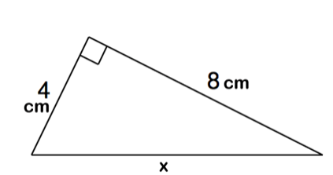

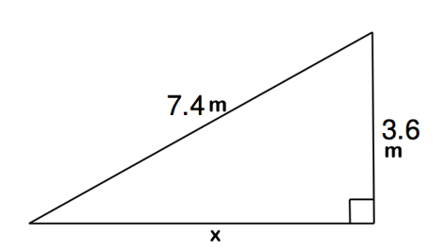

- Determine whether or not the following triangle has a right angle (Is it a Pythagorean triplet?):
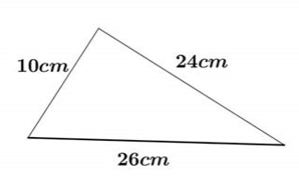
Math 8 Lesson 2.6 – Cubes and Cubes Roots Muscardin

Any whole number multiplied by itself “twice” will result in a _____________________________.

Perfect Cubes:
Number | Number Cubed | Perfect Cube

** You can use similar techniques for evaluating and estimating as you did with perfect squares and square roots **
Examples:
- Estimate:
$\sqrt[3]{46}$ $\sqrt[3]{24}$

- Evaluate using calculator. Round answer to the nearest hundredth.
$\sqrt[3]{50}$ $\sqrt[3]{74}$

