Math 9 Muscardin
Name: ________________________

Chapter 2 – Exponents

Test Date: ________________________________________

To do:

2.1 – Exponents
- Complete Notes ⃝

2.2 – BEDMAS
- Complete Notes ⃝

2.3 – Square Roots of Perfect Squares
- Complete Notes ⃝

2.4 – Square Roots of Whole Numbers
- Complete Notes ⃝
- Quiz 1 ⃝

2.5 – Pythagorean Theorem
- Complete Notes ⃝

2.6 – Cubes and Cube Roots
- Complete Notes ⃝

2.7/2.8 – Exponent Laws
- Complete Notes ⃝
- Quiz 2 ⃝

Chapter Assignment Handout ⃝

Write Unit Test ⃝

Math 9 Lesson 2.1 - Exponents Muscardin

When a number is __________________________________ by itself 2 or more times we can write it a shorter way, by using a raised number, called an _____________________________ or ______________________________.
The base in a power is the number being ___________________________. The exponent tells how many times to multiply the base by itself.

A negative is included in the base only when there are brackets.

A ________________________________ is the number in front of the base, and is multiplied by the base.
Examples:

Examples: Evaluate ${\left(-\frac{1}{2}\right)}^{2}$ and $-{\left(\frac{1}{2}\right)}^{2}$

Expand and evaluate:
${-1}^{6}$ ${-(-4)}^{3}$

Math 9 Lesson 2.1 - BEDMAS Muscardin

A special order of operations is to be done when there are several operations needed to simplify an expression.

B
E
D
M
A
S
Examples:
- $6^{2}-2^{2}$ 3. $\left(7+6×4\right)-{\left(\frac{9}{3}\right)}^{4}$

- $\frac{15+{(2+3)}^{2}}{16-7}$ 4. $1+\left[9+{(8-5)}^{2}\right]×2$

Math 9 Lesson 2.3 – Square Roots of Perfect Squares Muscardin

Finding the square root of a number is the ____________________________________ of a number squared. For example:

You can use prime factorization to find the square root of a perfect square. For example:

Another way to find the square root of a number is to find all the ___________________ of the number. Factors are all the numbers that _____________________________________ into it. For example:

Whenever a number has _____________________________________________________ that factor is the square root of the number. So a perfect square will have an _________________ number of factors. For example:
Examples:
- $\sqrt{81}$ $\sqrt{49}$ $\sqrt{400}$

- Solve for $x$
$x^{2}=36$ $x^{2}=25$ $x^{2}=9$

- Use prime factorization and factors to evaluate.
$\sqrt{332}$

Math 9 Lesson 2.4 – Square Roots of Whole Numbers Muscardin

The square root of a number can also be determined by ________________________________
____________________________ whose area is equal to that number. For example:

We can approximate the square root of a _______________________________ that is not a perfect square by determining what _________ perfect squares it is ___________________. We use the perfect squares as benchmarks. For example:

Once you have an approximate value you can use _____________________________________ to be more accurate. (Use a number line)

A more accurate way of finding square roots of non-perfect numbers is to use a _______________________________________. It is important to understand how this tool works in order to correctly input the calculation to get the correct outcome! For example:

Examples:
- Use your calculator to evaluate. Round your answer to 2 decimal places.
$\sqrt{88}$ $\sqrt{32}$

- Approximate:
$\sqrt{41}$ $\sqrt{13}$ $\sqrt{82}$

Math 9 Lesson 2.5 – Pythagorean Theorem Muscardin

Pythagoras, a Greek mathematician, showed that in any right triangle, there is a special relationship among the ________________________. A right triangle is one that has two sides that form a _____________________________________. The side opposite the right angle is called the ____________________________ and the two shorter sides are called ___________.
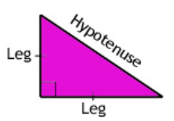
He found that: The area defined by the square of the hypotenuse equals the sum of the areas defined by the squares of the other two sides.
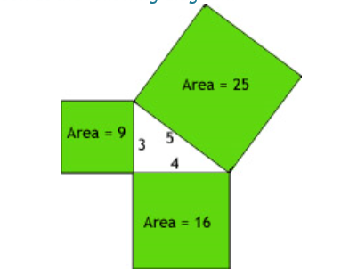

Hence,

Examples:
- Solve for the unknown in each of these right triangles:
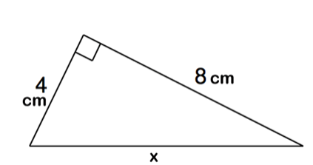

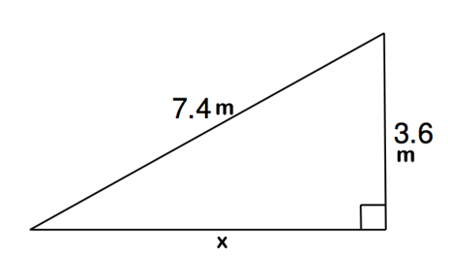

- Determine whether or not the following triangle has a right angle (Is it a Pythagorean triplet?):
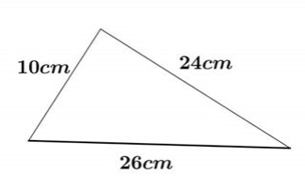
Math 9 Lesson 2.6 – Cubes and Cubes Roots Muscardin

Any whole number multiplied by itself “twice” will result in a _____________________________.

Perfect Cubes:
Number | Number Cubed | Perfect Cube

** You can use similar techniques for evaluating and estimating as you did with perfect squares and square roots **
Examples:
- Estimate:
$\sqrt[3]{46}$ $\sqrt[3]{24}$

- Evaluate using calculator. Round answer to the nearest hundredth.
$\sqrt[3]{50}$ $\sqrt[3]{74}$

Math 9 Lesson 2.7/2.8 – Exponent Laws Muscardin
You can use the exponent laws to simplify an expression involving powers:
- To multiply powers with the same base, ________________ the exponents
- To divide powers with the same base, ____________________ the exponents
- To raise a power to an exponent, ____________________ the exponents
Hence,
Product of Powers $(a^{m})(a^{n)}=a^{m+n}$
Quotient of Powers $\frac{a^{m}}{a^{n}}=a^{m-n},a≠0$
Power of a Power $(a^{m})^{n}=a^{mn}$
Raising a power to a Product ${\left(a×b\right)}^{n}=a^{n}×b^{n}$
Raising a power to a Quotient ${\left(\frac{a}{b}\right)}^{n}=\frac{a^{n}}{b^{n}}$
Zero Power $a^{0}=1$
Negative Power $a^{-1}=\frac{1}{a}$

Examples: Simplify
- $\left(3^{2}\right)\left(3^{4}\right)$

- $6^{5}÷6^{3}$

- ${\left(4^{2}\right)}^{5}$

- $\left(x^{6}\right)\left(x^{5}\right)$

- $x^{7}÷x^{2}$

- ${\left(x^{5}\right)}^{4}$

- ${\left(-2\right)}^{7}{\left(-2\right)}^{3}÷{\left[{\left(-2\right)}^{2}\right]}^{3}$

- $\frac{{\left(y^{3}\right)}^{5}}{(y)\left(y^{4}\right)}$

- ${-(453)}^{0}$

- ${(2^{3}×3^{2})}^{2}$

