Math 9 Muscardin
Name: ________________________

Chapter 6 - Geometry

Test Date: ________________________________________

To do:

6.1/6.2 – Equivalent Ratios
- Complete Notes ⃝
- Quiz 1 ⃝

6.3 – Scale Models
- Complete Notes ⃝

6.4 – Similar Triangles
- Complete Notes ⃝
- Quiz 2 ⃝

Chapter Assignment Handout ⃝

Write Unit Test ⃝

Math 9 Lesson 6.1/6.2 – Equivalent Ratios Muscardin

A ratio is a __________________________________________ of amounts.
There are many ways to compare and express ratios:
- Part-to-part
- Part-to-whole
- Multiple term ratios
Part-to-part
Ratios that compare one part to another part:

Part-to-whole
Ratios that compare one part to the whole group:

**Part-to-whole ratios can also be expressed with fractions and percents.

Multiple term ratios
Multiple term ratios will compare more than 2 amounts:

Practice:
- A juice from concentrate instructs that you need to combine 3 cans of water with 1 can of frozen juice. What is the ratio of cans of juice to cans of water?

- Jenna has a bag full of school supplies. She has 4 pencils, 7 pieces of paper, 1 pen, and 2 erasers.
What is the ratio of erasers to pencils?

What is the ratio of pieces of paper to the total number of items in the bag? Express as a fraction and a percent:

Equivalent ratios are _______________ of numbers, written as ratios that are ________________ to each other. Equivalent ratios can be formed by _____________________ or ____________________________ the terms by the same non-zero number.

Practice:
- Write 3 ratios equivalent to 2 : 6

- Write a ratio equivalent to $\frac{18}{12}$ in lowest terms

- A class of 28 students had some blue-eyed students and some brown-eyed students. The ratio of blue-eyed to brown-eyed was 4 : 3. How many blue-eyed students were in the class?

Math 9 Lesson 6.3 – Scale Models Muscardin

An enlargement of an image ________________________ its size but does not change its ____________________. An image expands its size by a ______________________________. This can be described by the following ratio:
$$\frac{Enlargement}{Original}=\frac{Scale Factor}{1}$$

A reduction of an image _______________________ its size, or makes it smaller, but does not change its _________________________. In this case, the scale factor will be a fraction less than 1. For example:
$$\frac{Reduction}{Original}=\frac{Scale Factor}{1}$$

To find a scale factor, given the original figure and its enlarged or reduced size, we need to measure _______________________________ of corresponding sides of both the original and the changed figure, and compare the changed version to the original version. Hence,

$$Scale Factor= \frac{Changed Figure}{Original Figure}$$
Examples:
- Enlarge the square by a scale factor of 2

- Reduce the triangle by a scale factor of $\frac{1}{2}$
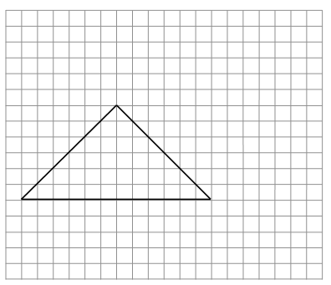

- Identify the scale factors for each of the following:
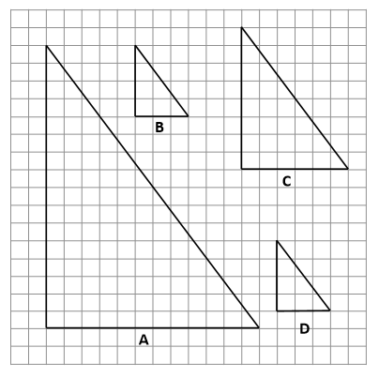
- From A to B

- From C to D

- From D to B

- From A to C

A scale diagram is used to draw an object when it is ___________________________________ or _______________________________ to draw the object to its actual size. For example:

The scale diagram has a scale factor that is the ratio of the length of one of the dimensions in the diagram compared to the corresponding dimension of the actual object. For example:

To find the scale we must write each term of the ratio in the same _______________________ units and reduce it to lowest terms. For example:

To find the actual length of one dimension of an object, given the scale and the length of the corresponding dimension in the drawing, use a _______________________________________ to solve for the unknown. For example:

Examples:
- Below is a scale diagram of a snowboard. The scale used is 1:36
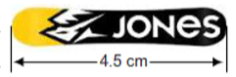
What is the actual length of the snowboard?

- The official NHL hockey puck has a diameter of 7.6 cm. below is an image of the hockey puck with a diameter of 16.2 mm. Calculate the scale factor used to create the drawing of the hockey puck.
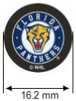

Math 9 Lesson 6.4 – Similar Triangles Muscardin

Two triangles are similar if the ratios of corresponding sides are ______________________.

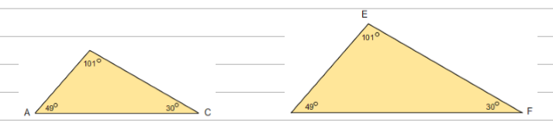

Two triangles are also similar if the corresponding pairs of ____________________ are equal.

Examples:
- Write the ratios of the sides and the corresponding angles:
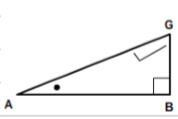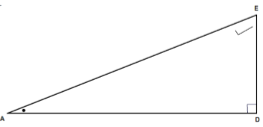
- Find the unknown side lengths

