Research Project Packet
English 10
Karen Burgess
Winter 2021

Introduction to the Research Project Basic Requirements: Topic: (e.g. Social Justice Issue)
Word length: (e.g. 1500 words or 6-8 pages)
Minimum number of outside academic sources: (e.g. 5-10 max 4 online sources)
Citation Style: ( APA)

Part 1
Research, notes and planning /10
Thesis statement and paper proposal /10
Outline Organization /10
Annotated Bibliography /20

Part 2
Rough Draft /15
Peer/ Parent Edit /10
Final Draft /25

Total /100

Section Breakdown

Research / Notes / Planning
- Decide on a topic of interest
- Run topic by Mrs. Burgess or Ms.Prsynuk for approval
- Seek out sources in the library and online
- Review sources, take notes and create note cards. Use Cornell note-taking process

Thesis / Paper Proposal
- Draft a short 250-word proposal for your paper. What will you write about, and how do you know you will be able to find enough source information. Give examples of sources you have and your potential thesis.
- Show Mrs. Burgess your proposal, and meet with him for feedback
Outline
- Draft and outline of each of your key arguments
- Create an annotated bibliography; provide a full bibliographic citation. Describe the background of the author, indicate the score of the text, outline the main argument, indicate the intended audience.
- Write your rough draft
- Review rough draft and add transitions, double-check spelling, review grammar and in-text citations.
- Have a peer or a parent or both edit your paper. Keep their feedback separate.
- Complete revisions, type your final copy
- Submit and celebrate your hard work.

APA Format for Beginners
APA format is a style guide that most colleges utilize to format essays and formal writing. It is usually used in science and history classes. We are going to begin the process of formatting papers to the correct APA format as this will be integral to your later classes.
The following guide will help you identify what APA papers look like, how to create citations, and how to format the paper as a whole. For 10th students, the major APA format guidelines that we want to see you master are the following:
- Running Header
- Page Numbers
- Double-spaced
- In-text citations
- Title Page
- Abstract Page
- Reference Page

Where Can I Find Reliable Sources?
Research Guide: Assessing Sources Evaluating the credibility and validity of a resource can be very difficult, particularly when doing research using the Internet. Below are some basic guidelines to help you select reliable resources and use those to learn accurate information about a given subject.
Characteristics of Reliable Sources Authority: Who is sponsoring the information?
The URL can provide information about the origin of the resource. The following are examples of ways you can determine the type of organization that is sponsoring the content for a specific website
Sites ending in…. .
edu are usually educational institutions and generally a good source of information.
.gov are government websites and usually good sources for statistical information
.org are typically non-profit organizations often set up as a public service.
Be on the lookout for political agendas and biases. Example: If you are looking for information about gun control, then you might check .gov sites for statistics related to gun ownership, laws, etc. Sites affiliated with specific biases on gun ownership will probably be listed a .org sites (handguncontrol.org or nrahg.org) Blogs While interesting, these are usually not fact-based and as a general rule should not be used for conducting research
Online magazines or journals These articles often contain a detailed bibliography and site specific resources as evidence for claims and statistics Online news sources, virtually every network and cable news station has an online site as do local affiliates. It is important to realize that while they do provide news, they are also involved in the entertainment industry and may present some information that is opinion vs. fact-based.
Television/Internet video news broadcasts When viewing video, keep in mind that if it is not from a source that can be accurately documented with origin, date, and key information like who, what, when, where, why and how, then the source may not be credible.
Accuracy: Sources for the factual content on the site are clear. There is someone verifying the accuracy of the information being presented. Verify the author’s credentials. Example: Dr. Robert Green is cited as a physician who was in charge of a study that produced specific results or the Center for Disease control provided certain statistical data.
Objectivity: The content is provided for public service or educational use. These sites usually provide links to additional information and are free of advertising for products related to the topic.
Timeliness: The date of the information and/or the last update is clearly stated on the page. Websites dedicated to reliable source:
What are In-Text Citations?
Generally, in-text citations are citations that cite that you have used another author's words.
For a direct quote: (include author's surname, the date published and page number if available).
Example:
One study found that “the listener's familiarity with the topic of discourse greatly facilitates the interpretation of the entire message” (Gass & Varonis, 1984, p. 85)
For a paraphrase or summary of author's ideas: (include author's surname, the date published and page number if available).
Example:
Many homeless experience isolation in part due to suffering from abuse or neglect during their childhood (Rokach, 2005).
Note: The example keeps the idea of the original writing but phrases it in a new way.

Here is an example of how a paragraph with in-text citations will look.
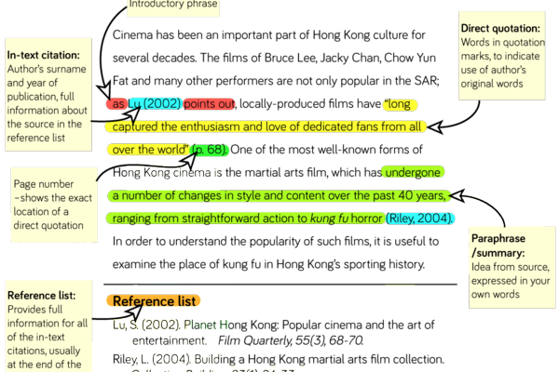
What is a Reference Page?
APA format style is used across the country and world as a guide that helps students and professionals properly credit the information that they use. The reference page of an APA essay or paper gives the specific citations in alphabetical order on the last page of the paper.
Do I Need to Use All of the Examples in the Sample Paper?
No, of course not. There are many rules for APA papers and not all of them will apply to your paper. For example, if you are not using tables and charts, you will not need to know that citation information. However, it is still provided to you for your future endeavours.
Do I need to Use All of the Examples in the Sample Paper?
No, of course not. There are many rules for APA papers and not all of them will apply to your paper. For example, if you are not using tables and charts, you will not need to know that citation information. However, it is still provided to you for your future endeavours.

