UNIT 2 – EARNING AN INCOME – ANSWERS

ASSIGNMENT 1 – WAYS OF EARNING AN INCOME  Matching.  ASSIGNMENT 2 – GROSS PAY  1) $834.80  2) $1215.50  3) $9.88  4) $6000  ASSIGNMENT 3 – KEEPING TRACK OF TIME  1) a) 3:00 or 3h  c) 2:30 or 2.5h  e) 4:00 or 4h  ASSIGNMENT 4 – TIME CARDS  1) a) 15.75 hours  b) $148.84  2) a) 20 hours  b) $255.20 | ASSIGNMENT 5 – OVERTIME PAY  1) $537.81  2) $5436.16  3) $910.71/week  ASSIGNMENT 6 – OTHER WAYS TO EARN AN INCOME  1) $377.50  2) $51  3) $3.75 / qt  4) 550 words  5) $94.31  6) $15 000  7) 4.7%  8) $414.75  9) 10.9%  ASSIGNMENT 7 – ADDITIONAL EARNINGS  1) $34.22 / h  2) $275 bonus is higher  3) $461.50  4) 28% is higher  5) $208.10  6) 12.1%  7) $121.30 | ASSIGNMENT 8 – NET PAY AND DEDUCTIONS  1) $112.50  2) $455.62  3) 23.1%  4) 1.73%  ASSIGNMENT 9 – DEDUCTION TABLES  1) Provincial taxes - $54.40  Federal taxes - $116.80  ASSIGNMENT 10 – PAY STATEMENTS  1) b) $86.12  d) 8.03%  2) net pay: $2321.86  ASSIGNMENT 11: MORE  1 b) $347.63  2 a) $937.50  b) 24 pairs  3 a) $12/haircut  b) $96  c) $384.00  4 b) $794.25  5 a) $20,000  b) 381 395

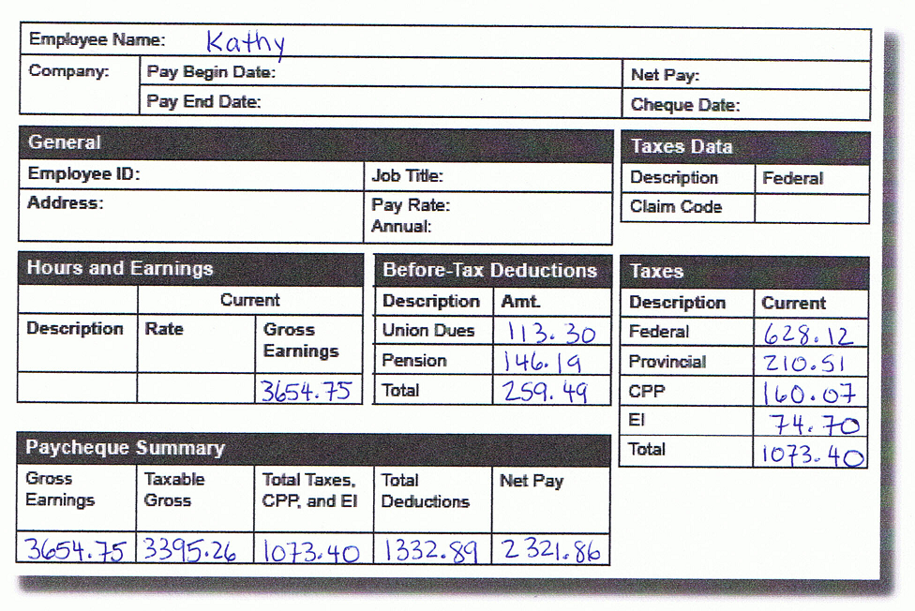
Union Dues - $3654.75 × 0.031 = $113.30
Pension - $3654.75 × 0.04 = $146.19

Taxable Income - $3654.75 - $259.49 = $3395.26

Federal Tax - $3395.26 × 0.185 = $628.12
Provincial Tax - $3395.26 × 0.062 = $210.51

Total Deductions - $1073.40 + $259.49 = $1332.89

Net Pay = Gross Pay – Total Deductions
Net Pay = $3654.75 - $1332.89 = $2321.86

