WHERE I’M FROM
"If you don't know where you're from, you'll have a hard time saying where you're going."
Wendell Berry, among others, has voiced this idea that we need to understand our roots to know our place in the world. George Ella Lyon wrote a poem called "Where I’m From." The poem lends itself to imitation and makes a wonderful exercise of exploration in belonging.

George Ella Lyon’s poem “Where I’m From” is full of details and anecdotes that maker her unique. Where you’re from can never be the same as where someone else is from. Once you start writing, you’ll be surprised at how unique you truly are and, hopefully, you’ll look at your background and history in a way you never have before. And, the best part? You will not only produce a poem, but you will produce an artifact that you can share with your family, friends, and classmates to show the world where you’re really from.

Goal: I will describe my background through poetry. Through planning and drawing, I will create a list of places I’ve lived, details about my family and its heritage, my home(s), and everything else that makes me unique. I will show I can do this by writing a poem called, “Where I’m From,” which will contain biographical information about myself.

DUE DATES:
  - Pre-Write:
  - Rough Draft: (by the end of class)
  - Peer Review: (you must have your rough draft complete when you come into class to participate in peer review)
  - Edit and Revise:
  - Final Copy (print out two):
  - Sharing! ☺
We will all be sharing our poems in class on (yes, even the teacher will share!).
- Everyone must comment at least twice to receive participation points. Some of you will comment more than once – that’s fine! This will push us all to be better listeners and writers.

WRITING PROCESS

Step 1: Planning/Brainstorm/Family Portrait
Think about what makes you YOU. Answer the questions and fill out the Family Portrait form.

Step 2: Rough Draft
Handwrite a rough draft of your poem. As long as you incorporate the “I am from” repetition, the form of the rest of the poem is up to you. Make sure to give it a title. “I Am From...” or “Where I’m From” is fine.
*If you are really struggling to come up with your own structure, ask me for a template.

Step 3: Edit and Revise (use a red pen)
Revise your poem. This means you are looking for places where you should be more specific, descriptive or could include a poetic device. Can your reader visualize what you are describing? Use your five senses and poetic devices (metaphors, similes, alliteration, onomatopoeia, personification rhyme) to help create a sense of being there.

Bad example: I am from fried chicken and corn bread.
Good example: I am from juicy, crispy chicken – buckets full and Kentucky Fried, from Granny Mae’s top- secret corn bread factory, kept on lock-down at Fort Knox.

Edit your poem. You are now looking for convention errors. Circle any words you think may be spelled incorrectly. Underline words that need to be capitalized. Add punctuation where appropriate.

Step 4: Peer Review (use a pen)
Have a partner read your poem/you read a partner’s poem.
  - Mark any area that needs clarification or is confusing to you with a (?) question mark.
  - Circle any misspelled words.
  - Underline words that should be capitalized.
  - Put a star next to any areas that could use more descriptive language.

At the bottom, draw a 2x2 comment box and give the following feedback:
+ 1 positive comment  (What did you like? What did they do well?) | - 1 comment of improvement  (What could they do better? What was confusing? Where were they making the most errors?)
+ 1 positive comment  (What did you like? What did they do well?) | - 1 comment of improvement  (What could they do better? What was confusing? Where were they making the most errors?)

Step 5: Rewrite
Now that editing and revision is completed, rewrite your poem by hand (no typing), fixing all that was marked in the previous steps. You may also add or change things that your reviewer did not suggest; this is your opportunity to get everything in the poem you want.

Step 6: Final Draft
Type your poem. Include your title, name and date at the top. The font should be size 12 and easy to read.

WHERE I'M FROM

by George Ella Lyon
I am from clothespins,
from Clorox and carbon-tetrachloride.
I am from the dirt under the back porch. (Black, glistening,
it tasted like beets.)
I am from the forsythia bush the Dutch elm
whose long-gone limbs I remember as if they were my own.
I'm from fudge and eyeglasses, from Imogene and Alafair.
I'm from the know-it-alls and the pass-it-ons,
from Perk up! and Pipe down!
I'm from He restoreth my soul with a cottonball lamb
and ten verses I can say myself.
I'm from Artemus and Billie's Branch, fried corn and strong coffee.
From the finger my grandfather lost to the auger,
the eye my father shut to keep his sight.
Under my bed was a dress box spilling old pictures,
a sift of lost faces
to drift beneath my dreams. I am from those moments-- snapped before I budded -- leaf-fall from the family tree.

Sample #1
I am from Texas
WHERE I'M FROM (student samples)

Sample #2
I am from hairspray

where deep in the heart lies Austin.
I am from the sunny Saturday afternoons of Texas Longhorn football games.
I am from sports
and the lessons that I learn from these games I play with all my ability and enjoy the victories.

I am from my family, friends, and awesome food.
I am from my grandmother’s warm pies and my parents’ cooking, from which
I grew to be a large boy.
I am from Texas barbeque
which smells and tastes like none other. Although I cannot have it right now
I can still remember.

I am from Tennessee
where I live at the Foothills of the Smokies and enjoy hiking on clear days.
I am from lessons in literature and the sounds of a saxophone. I am from the “try your hardest” and “never give ups.”
I’m from my hard work
and the present as I continue on life’s journey.
From braces and rubberbands. I am from lightning bugs
Fluttering in the summer night sky.

I am from Belle
The cute little puppy
We rescued from the pound And Smoky the cat
Whose death still touches my heart.

I am from Papaw’s goulash And Momma’s pumpkin pie From Dad’s overbearing Protectiveness of his little girl.

I am from outrageous Eleven foot Christmas trees
And joyous Thanksgiving feasts.

I am from French immigrants
From 1692 and New Paltz, New York
I am from Louis Bevier and Marie Le Blanc. I am from the American dream
From broken despair and gained hope
I am the present, past, and future, History in the making.

PLANNING: FAMILY PORTRAITS (PART 1)

Please share a special family memory that represents your unique cultural heritage.
Step 1: Draw your memory. Stick figures are acceptable. It does not need to be colored.

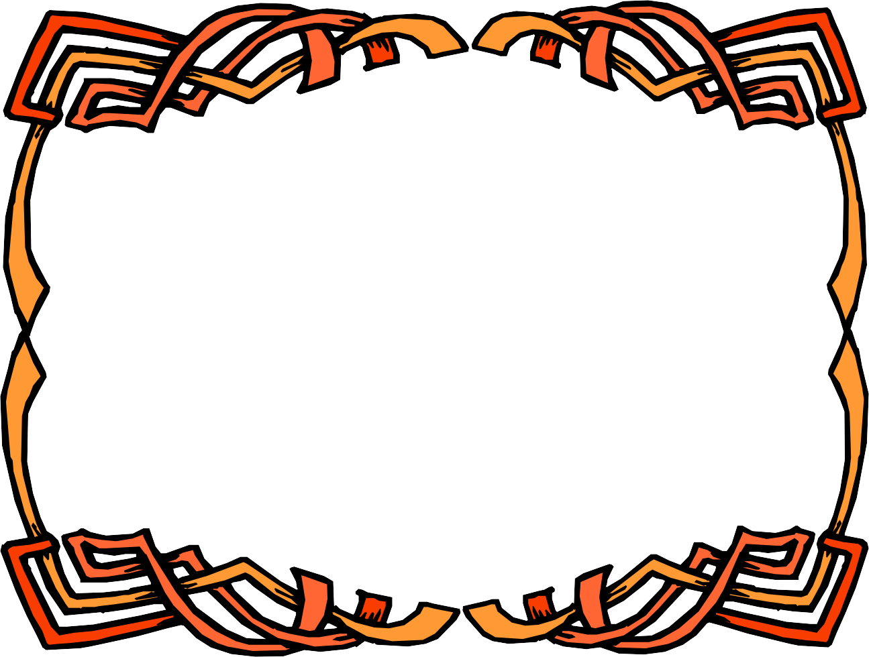

Step 2: Describe your memory/picture

PLANNING: DETAILS (PART 2)

Answering the following questions will help prepare you to write your “Where I’m From” poem.
- Describe where you live. What does it look like? What does it smell like? What does it feel like? (This could be your actual house, or it could be another place that represents where you are from – neighborhood, city, state)

- What objects or belongings can be found in your home or room? (List at least three.)

- What are the names of people in your “family” (they could be alive or deceased, they do not need to be blood relations)? Try to go back as far as you can in your family tree.

- List two or three family traditions.
•

•

•
- What phrases, words or sayings are important to you or to members of your family?

- What are some beliefs that represent where you are from? (religious/spiritual/cultural)

- What foods are important to you or your family?

- List 2 or 3 important childhood memories.

•

•

•

- Describe the weather where you are from.

- What do people do where you are from?

- What are your favorite things to do?

PLANNING: TEMPLATE
First Stanza:
I am from (specific ordinary item)
from (product name) and (another product name) I am from the (home description) Adjective that describes the above home description ,

It (tasted, sounded, looked , felt –choose one) I am from the (plant, flower, or natural item) , the (plant, flower, or natural item) (Description of natural item) I’m from the (family tradition) and (family trait)
from (name of family member) and (name of family member)
and (another name) I’m from the (description of family tendency) and (Another family tendency)
Second Stanza:
From (something you were told as a child) and (another thing you were told as a child) I’m from (representation of religious or spiritual beliefs or lack of it)
, (further description of spiritual beliefs) I’m from (place of birth and family ancestry) , (Two food items that represent your ancestry) and . From the (specific family story with a detail about a specific person)

the (another detail of another family member) .
I am from (general statement with DETAILS about who you are or where you are from)

